Many children get mobile phones and TikTok at
the age of ten
About the research question and methodology
In children's media consumption, the use of different devices and platforms changes and shifts more quickly in the direction of new technology than in older age groups.
The goal of the research was to explore the process of digital education, including the devices usage and the viewing of various media contents. In the course of the complex, multi-step research, interviews have been conducted by parents of the preschoolers (400 interviews nationwide), the lower/upper elementary students and their parents (400 interviews nationwide) and the preschooler/elementary teachers (400 interviews nationwide). In the case of preschoolers, focus group discussions were also organized with children aged 4-6. The research took place in September and October 2022 by the co-operation of NMHH, National Media and Infocommunications Authority, and MEME, Association of Hungarian Electronic Broadcasters.
A mobile phone for the tenth birthday, a laptop for distance learning
Many parents of young children are concerned with the question: what is the optimal age when it is worth introducing my child to the world of digital devices and the Internet? They have conflicting feelings about the early introduction of digital devices: on the one hand, it might be worth starting early so that their child arrives digitally mature in the school system. On the other hand, there are those dangers and threats that we will talk about in more detail later in the article.
In response to the above question, every parent obviously has their own idea, their best recipe, and there may even be significant differences. What seems to be no significant difference, however, is the optimal time for the release of smartphones. It can also be seen in Figure 1 that a significant number of parents choose a smartphone as a gift for their child's tenth birthday, since only a quarter of 9-year-olds and more than half of 10-year-olds own a smartphone. It is safe to say that the smartphone almost bursts into the lives of upper elementary students, most of them get their first mobile phone at the border between the lower and upper grades.
Of course, this presents a new challenge to the leaders of educational institutions, who try to limit the use of telephones within the school within strict limits. There are few schools where the usage of digital or mobile devices during school hours is not restricted: the main practice is that the mobile device must be handed in in the morning. Even though the teachers consider the usage of mobile phones, computers, and the Internet to be the most harmful and at the same time the least safe, they also admit that in the context of the digital culture subject, students can acquire skills and knowledge that they can use in other lessons. The education of the subject is considered essential, the use of digital devices should be a part of their everyday life, but at their age it is still only within a controlled framework.
There is one more IT device that is worth mentioning: the laptop is the second most common device for 14-year-olds, although it peaks at roughly 25-30% in this age group [Figure 1]. The appearance of the laptop in households and in education was obviously helped by the government measures taken during the coronavirus epidemic and the transition of the education system to distance learning.

Figure 1.
Preschoolers, lower/upper elementary students: decreasing parental influence, increasingly frequent compromise
While preschoolers accept the exclusive parental decisions almost unconditionally and do not use the Internet alone, as they get older, the influence of their parents decreases, and moms and dads are more and more forced to compromise [Figure 2]. We can say that the age group of upper elementary children is a completely new world, independence and a bit of rebellion have begun. Parental control has weakened spectacularly, in most cases a compromise solution is reached, and then this is even the best case.

Figure 2.
In preschool age, we can hardly talk about internet usage and online games, at their age the main role is still playing by traditional toys, such as dolls, toy cars, role-playing games, dress-up games, skill-developers, as well as playgrounds and playhouses among the programs outside the home. On the other hand, online games are already available for lower elementary students, but still under relatively strong parental supervision. For upper elementary students, parental supervision is already lagging.
The three age groups are well separated by the time spent on the Internet and the time allowed by parents [Figure 3]. This period is always longer on weekends.

Figure 3.
In addition to the daily duration allowed for Internet use, very strong characteristics can be observed in each age group. In preschool age, the almost exclusive purpose of internet access is to watch their favorite fairy tales and cartoons - primarily on YouTube and some fairy tale sites. Although the main purpose of using the internet for lower elementary children is still to watch cartoons and children's films, online games with short, colorful, and funny videos appear especially as they move towards the top of the age group - for girls, more dress-up, animal, care-based games, and for boys Minecraft and Fortnite. In the same age group, internet access plays an increasingly important role in education and foreign language learning from year to year. As we mention in the later chapter of the article, social media appears more seriously in this age group, including TikTok rather than Facebook.
10-15-year-olds spend almost 2 hours on the Internet on an average weekday, and almost 3 hours on weekends. In this age group, social media flourishes, the main purpose of surfing the Internet, its main activity is checking Facebook, Insta and TikTok profiles, posting, exchanging Messenger messages. Two out of three are on Facebook, but TikTok has a strong presence as well, every second or third child uses it. Among upper elementary students, internet use is no longer only for social media, learning, and foreign language education, but it is also a good tool for keeping in touch with distant relatives and friends.

What are parents and teachers afraid of?
Parents and teachers see the advantages and disadvantages of using digital devices, social media and television sets in roughly the same way, but teachers rather perceive the threat and the danger in it.
But let's start with the benefits! Controlled conditions for watching TV and using the Internet, including the choice of content and time limit, can be an advantage, especially for elementary school students. On these channels, they can acquire new knowledge, expand their horizons, and the supporting role played by the Internet in foreign language learning is acknowledged by the majority. The supporting role of the Internet in learning is mentioned by the parents of both lower and upper elementary students. Keeping in touch with distant relatives and friends helps the everyday life of upper elementary students, this kind of internet use is not yet developed in lower elementary students.
Parents and especially teachers are divided as to whether watching TV really expands children's vocabulary [only 26-30% think so]. Traditional book reading is still more suitable for this task, regardless of whether it is fairy tales, youth, contemporary or fiction. It must be accepted that reading to children in preschool and independent reading in elementary school cannot be replaced. When it comes to vocabulary expansion, watching TV can also backfire.
Parents, elementary and preschool teachers consistently see the main risk in a sedentary lifestyle, a decrease in physical activity, and thus in the deterioration of children's physical condition. Watching TV and using the Internet takes time away from exercising, going outside, and playing sports. 38-44% of parents are afraid of this danger, while teachers consider the issue much more worrying, 62-78% of them share this opinion.
Elementary school teachers mention other serious risks. These two activities and the excessive use of digital devices can reduce children's social network, deteriorate the real quality of their friendships, and lead to integration problems. Through the Internet and TV channels, they can access content that is harmful to their development (aggression, sexuality) without parental or teacher supervision. According to preschool and elementary teachers, these two platforms can distort a child's personality and behavior to a harmful extent. According to preschool teachers, it can also cause concentration problems and exhaustion.
According to preschool teachers, the use of laptops, computers and the Internet at this age is still harmful and unjustified, and although learning how to handle digital devices is essential over time, their use in preschoolers can have harmful consequences, such as the children's healthy daily routine (e.g., enough sleep). overturning, the sedentary lifestyle, but it also sucks the air out of family and other social activities.
What trends do we see in the near future?
Perhaps the most decisive factor is the unfavorable macroeconomic climate in which we are already in full swing. According to this research, this will affect the demand side and consumer decision-making at several points. On the one hand - this is supported by another module of this research series - it significantly reduces the market for nonlinear services, we expect significantly less interest in paid content in the next year or two in this economic environment. On the other hand, the market for information technology devices may also decline, since in such a period, which significantly affects the wallets of households, vital, basic consumer goods (the so-called inferior goods) come to the fore, and households can postpone the purchase of higher value, but by no means essential (luxury) goods, such as laptops, portable smart devices, and smart TVs. Another factor that works against paid content is the fact that we have just passed an epidemic period that forced families to stay indoors. However, with the easing of the epidemic situation and the lifting of restrictions, alternative pastime activities are given space, families can organize programs outdoors, our children have returned to playhouses, playgrounds, and slide parks, and can attend training sessions again. What does this mean for paid content? It is by no means good news: with the end of room confinement, the role of paid content in spending leisure time is weakening, and this trend is likely to be reflected in demand as well.
If we have already mentioned the epidemic situation, it is also worth emphasizing its positive outcome: after the initial difficulties, it turned out that the infrastructure of the colleagues working in the schools and the institutions were in most cases suitable for a relatively quick transition, and in the situation born of necessity, the various smart devices quickly spread in schools. Not only did the schools' IT equipment improve as a technological requirement for distance education, but the receiving side, namely the children's households, also invested in distance education. Preschool and elementary teachers stated that the operators of the institutions provided extensive support in most cases, more than 80% of the time, in installation, maintenance, and training of colleagues. And although in the next period, the students will return from distance learning to face-to-face teaching practice, the achievements of the past two years - achieved as a result of unfortunate events - will remain with us: more digitally trained teachers, more modern infrastructure in institutions and at home.
TikTok vs Facebook. It has already been felt from other research that among young people, Facebook has a kind of negative, outdated, outdated, but definitely unfavorable image. This age group associates Facebook more with middle-aged and elderly adults, for them TikTok is the "cool" social media platform. In the case of upper elementary students, we are only experiencing TikTok catching up, but in the case of lower elementary students, TikTok is already becoming more and more popular, almost as much as Facebook, but there is a risk that it may even exceeds it.
Game of Screens: how long will the dominance of smart TVs last in the battle of the screens? For a while for sure. In all target groups of the research, the rather obvious assumption that viewing media content on any device is no longer as convenient and practical as on a TV set after a certain period of time was confirmed. In all target groups of the research, the rather obvious assumption that viewing media content on any device is no longer as convenient and practical as on a TV set after a certain period of time was confirmed.
Bogyó és Babóca – PAW petrol – Minecraft and Fortnite. This can be considered the most typical media consumption evolution timeline – in addition to the previously mentioned social media usage trends. Children most often start preschool with Bogyó and Babóca and other fairy tales by Erika Bartos (for example, Anna, Peti, Gergő). The cute little animals of the forest are replaced by Paw Patrol, Bing Bunny, Peppa Pig, and cartoon series for older preschoolers. It is important to note here that children of preschool age use the Internet even with strong parental control to watch fairy tales. Online games only rarely appear - and when they do, they are mainly skill developers, coloring and jigsaw puzzles chosen by the parents. Lower elementary students are the first to see online games with greater frequency: two of them stand out, Minecraft and Fortnite.
In the end, we have actually gone through the trends that, in our opinion, best describe the present and the near future, and our further interesting, but perhaps no longer decisive, predictions can be seen in Figure 4.
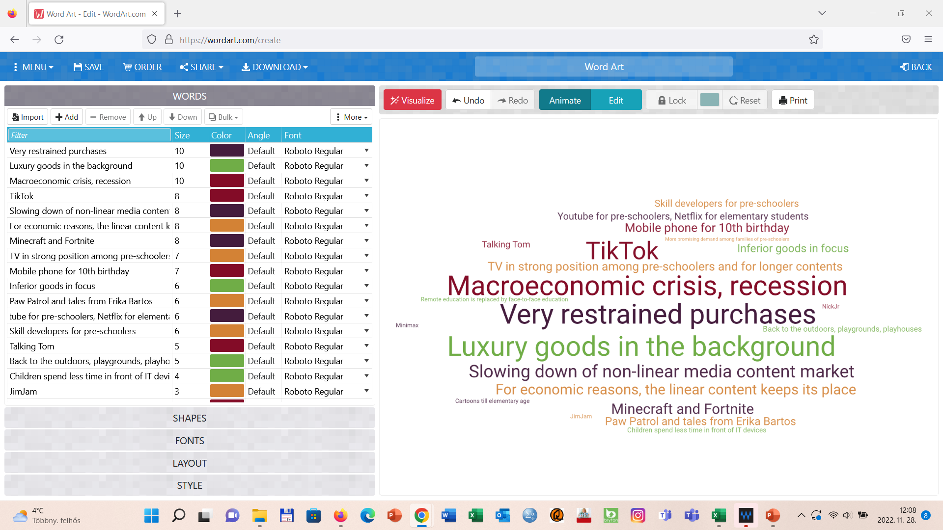
Figure 4.
The survey was carried out by Inspira Research in September 2022, with a nationally representative sample of 3,000 Hungarian households.

